**Joy in my heart**

**Reading: John 15:9-11**

Jesus said to his disciples, “Just as the Father has loved me, I have loved you. Now remain in my love. If you obey my commands, you will remain in my love. In the same way, I have obeyed my Father’s commands. I have told you this so that you will have the same joy that I have. I also want your joy to be complete.”

**Reading: Matthew 13:44-46**

Jesus said, “The kingdom of heaven is like treasure that was hidden in a field. When a man found it, he hid it again. He was very happy. So he went and sold everything he had. And he bought that field.

Again, the kingdom of heaven is like a trader who was looking for fine pearls. He found one that was very valuable. So he went away and sold everything he had. And he bought that pearl.”

**Thought about the reading**

The readings today are about the joy that Jesus gives us when we choose to follow him. In the first reading, Jesus tells his special friends that he wants them to know the same joy that he has. The second reading has two stories that Jesus told to show us what that joy is like.

It is like the joy that someone feels if they find treasure in a field, or a beautiful and valuable pearl. How would you feel if you found some treasure? You might feel excited and happy.

Having joy in our hearts does not mean that everything in our life will be easy. Sometimes things are hard, but with the joy of Jesus in our hearts, we have strength to do difficult things.

It is a bit like climbing a mountain. It is very hard work, but it is easier if we do it with friends and together we can think about how amazing it will be when we get to the top!

What gives us that joy? Knowing our sins are forgiven, that God loves us and has given us his Holy Spirit. Remembering that Jesus is always with us.

**Prayer**

Dear Jesus, thank you that you give me your joy in my heart. Thank you that your joy gives me strength when things are hard.

Please help me to remember all the things that Jesus has done for me that give me joy.

Amen

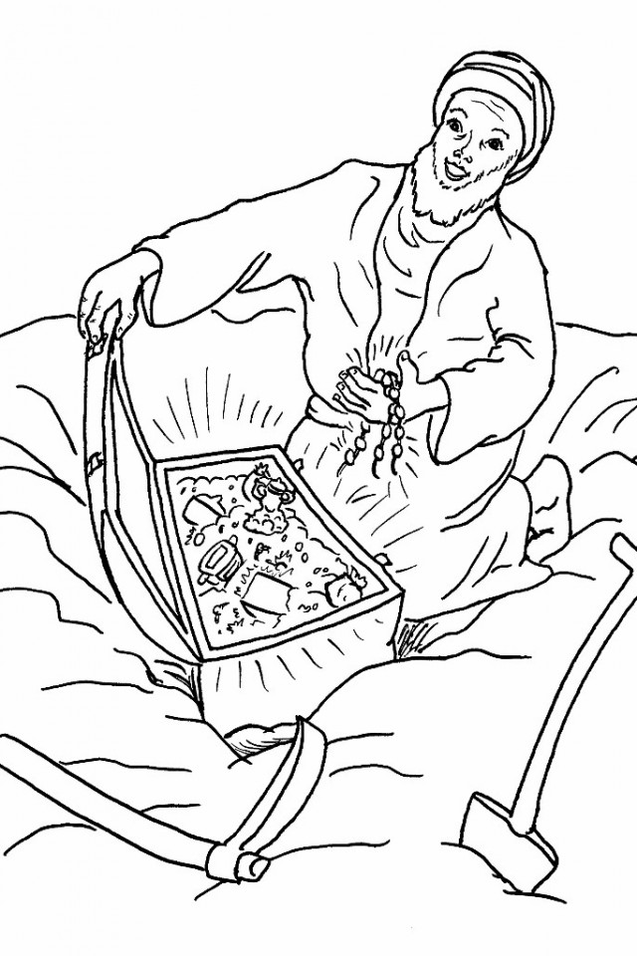

**Cambridge Causeway**

Autumn 2024

Bible Study notes

**What Jesus has done for me**

**6. Joy in my heart**

By Chrissy Cole